Scheme of work for jss1

Week 1; revision of last terms work

Week 2; types of building

Week 3; uses of building material

Week 4; drawing instrument

Week 5; care of drawing instrument

Week6; board practice

Week 7; board practice [lettering]

Week 8; free hand sketching

Week 9; sketching of work shop hand tools

Week 10; work bench fittings

Week 11; revision

Week 12; examination

Week 1; [Home](http://drivingtesttrack.in/index.htm)   ›   [Road Safety](http://drivingtesttrack.in/safe-responsible-driving.htm#195)   ›   Guidelines for Pedestrians

## Guidelines for Pedestrians

The most important safety tip to reduce pedestrian injuries and fatalities is to pay attention. You can significantly reduce your chances of being in a collision with a motor vehicle by obeying traffic rules and being aware of dangers posed by cars in your vicinity. Make eye contact with drivers if possible and make sure that they can see you.

### Pedestrians must

* Where possible, avoid walking next to the kerb with your back to the traffic. If you have to step into the road, look both ways first.
* Wear or carry something light coloured, bright or fluorescent in poor daylight conditions. When it is dark, use reflective materials (e.g. armbands, sashes, waistcoats and jackets), which can be seen, by drivers using headlights, up to three times as far away as non-reflective materials.
* Young children should not be out alone on the pavement or road ( see Rule 7 ). When taking children out, walk between them and the traffic and hold their hands firmly. Strap very young children into push-chairs or use reins.
* Always walk on the footpath, they are meant for you. Where there is no footpath, walk in the right side margin of the road so that you can see the traffic coming in the opposite direction.
* Cross roads where there are pedestrian crossings. They have been painted at great cost for your convenience.
* Where there are no pedestrian crossings, watch the traffic on both sides and cross when it is safe.
* You MUST NOT walk on motorways or slip roads except in an emergency.
* Never walk on the main carriageway, it could be fatal.
* Do not read newspapers or look at hoardings while walking on the road.
* Do not greet friends on the road. Take them to the footpath or the side margin.
* Do not come on to the main road while waiting for a bus. Stay on the footpath at earmarked bus stoppage.
* Where there are barriers, cross the road only at the gaps provided for pedestrians. Do not climb over the barriers or walk between them and the road.
* Do not run after a moving bus. Follow safety rules on the road and live long.
* You MUST NOT get on to or hold on to a moving vehicle.
* Don't "Drink and Walk." If you've been drinking, take a cab or a bus, or let someone sober drive you home.
* When walking at night, wear retroany type of crossing you should always check that the traffic has stopped before you start to cross or push a pram onto a crossing . Always cross between the studs or over the zebra markings. Do not cross at the side of the crossing or on the zig-zag lines, as it can be dangerous. You MUST NOT loiter on zebra, pelican or puffin crossings.

### We must follow the six-step crossing code whenever we have to cross the road

**THINK**  
What is a safe place to cross? Where can I see all the traffic properly? Make sure you are not hidden behind a parked car.   
  
**STOP**  
At the edge of the road where you have decided to cross.   
  
**LOOK and LISTEN**  
Look both ways, many time, to see if there is any traffic coming.   
  
**WAIT**  
For all the traffic to pass, and for road to be clear.   
  
**CROSS**  
Walk straight across the road.   
  
**KEEP LOOKING and LISTENING**  
Keep looking in all directions as you cross the road until you get to the other side.

Question

1. What is safety guideline
2. Who is a pedestrian

Week 2;

**Types of building**

The word ‘building’ is commonly considered to refer to an enclosed [structure](https://www.designingbuildings.co.uk/wiki/Structure) within which people can perform activities. The [Building Regulations](https://www.designingbuildings.co.uk/wiki/Building_regulations) suggest that the word 'building' refers to: ‘...any permanent or [temporary building](https://www.designingbuildings.co.uk/wiki/Temporary_building) but not any other kind of [structure](https://www.designingbuildings.co.uk/wiki/Structure) or erection’. For more information see: [Construction works](https://www.designingbuildings.co.uk/wiki/Construction_works).

|  |  |  |
| --- | --- | --- |
|  |  |  |
|  |  |  |

There are many ways of classifying types of building, including:

* Construction type.
* Use.
* Size.
* Style.
* Period.
* Design (for example, form, [structure](https://www.designingbuildings.co.uk/wiki/Structure) etc).
* Performance (for example, energy consumption, [accessibility](https://www.designingbuildings.co.uk/wiki/Accessibility) etc).
* Legal definition.
* Nature of occupancy / ownership.

This article presents a list of common types of building alphabetically (rather than by any one type of classification) with links to articles providing further information

|  |  |  |  |  |  |
| --- | --- | --- | --- | --- | --- |
| [Battersea.jpg](https://www.designingbuildings.co.uk/wiki/File:Battersea.jpg) | | |  |  | |
| [Temple church BristoliStock 000077184247 Small.jpg](https://www.designingbuildings.co.uk/wiki/File:Temple_church_BristoliStock_000077184247_Small.jpg) | | |  | [Maracana-stadium-brasil270.jpg](https://www.designingbuildings.co.uk/wiki/File:Maracana-stadium-brasil270.jpg)[Fabricstructure 280.jpg](https://www.designingbuildings.co.uk/wiki/File:Fabricstructure_280.jpg) | |
| [https://upload.wikimedia.org/wikipedia/en/thumb/9/99/Question_book-new.svg/50px-Question_book-new.svg.png](https://en.wikipedia.org/wiki/File:Question_book-new.svg) | This article **needs additional citations for** [**verification**](https://en.wikipedia.org/wiki/Wikipedia:Verifiability). Please help [improve this article](https://en.wikipedia.org/w/index.php?title=Building_material&action=edit) by [adding citations to reliable sources](https://en.wikipedia.org/wiki/Help:Introduction_to_referencing_with_Wiki_Markup/1). Unsourced material may be challenged and removed. *(December 2013)* *(*[*Learn how and when to remove this template message*](https://en.wikipedia.org/wiki/Help:Maintenance_template_removal)*)* | | |

[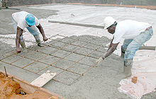](https://en.wikipedia.org/wiki/File:Concrete_rebar_0030.jpg)

[Concrete](https://en.wikipedia.org/wiki/Concrete) and metal [rebar](https://en.wikipedia.org/wiki/Rebar) used to build a floor.

[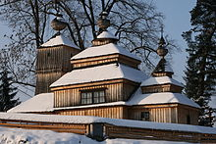](https://en.wikipedia.org/wiki/File:Bodruzal_cerkov06017008.JPG)

Wooden church in [Bodružal](https://en.wikipedia.org/wiki/Bodru%C5%BEal) in [Slovakia](https://en.wikipedia.org/wiki/Slovakia).

[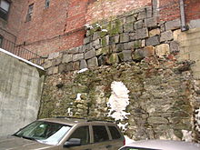](https://en.wikipedia.org/wiki/File:2008_BeaconHill_Boston_2302897829.jpg)

This wall in [Beacon Hill, Boston](https://en.wikipedia.org/wiki/Beacon_Hill,_Boston) shows different types of brickwork and stone foundations.

**Building material** is any material which is used for [construction](https://en.wikipedia.org/wiki/Construction) purposes. Many naturally occurring substances, such as [clay](https://en.wikipedia.org/wiki/Clay), rocks, [sand](https://en.wikipedia.org/wiki/Sand), and [wood](https://en.wikipedia.org/wiki/Wood), even twigs and leaves, have been used to construct [buildings](https://en.wikipedia.org/wiki/Building). Apart from naturally occurring materials, many man-made products are in use, some more and some less synthetic. The manufacture of building materials is an established industry in many countries and the use of these materials is typically segmented into specific specialty trades, such as [carpentry](https://en.wikipedia.org/wiki/Carpentry), [insulation](https://en.wikipedia.org/wiki/Building_insulation), [plumbing](https://en.wikipedia.org/wiki/Plumbing), and [roofing](https://en.wikipedia.org/wiki/Roofing_material) work. They provide the make-up of [habitats](https://en.wikipedia.org/wiki/Category:Human_habitats) and [structures](https://en.wikipedia.org/wiki/Architecture) including [homes](https://en.wikipedia.org/wiki/Home).[[1]](https://en.wikipedia.org/wiki/Building_material#cite_note-1)

## Contents

* [1 The total cost of building materials](https://en.wikipedia.org/wiki/Building_material#The_total_cost_of_building_materials)
  + [1.1 Economic costs](https://en.wikipedia.org/wiki/Building_material#Economic_costs)
  + [1.2 Ecological costs](https://en.wikipedia.org/wiki/Building_material#Ecological_costs)
  + [1.3 Energy costs](https://en.wikipedia.org/wiki/Building_material#Energy_costs)
  + [1.4 Social costs](https://en.wikipedia.org/wiki/Building_material#Social_costs)
* [2 Naturally occurring substances](https://en.wikipedia.org/wiki/Building_material#Naturally_occurring_substances)
  + [2.1 Brush](https://en.wikipedia.org/wiki/Building_material#Brush)
  + [2.2 Ice and snow](https://en.wikipedia.org/wiki/Building_material#Ice_and_snow)
  + [2.3 Mud and clay](https://en.wikipedia.org/wiki/Building_material#Mud_and_clay)
    - [2.3.1 Wet-laid clay walls](https://en.wikipedia.org/wiki/Building_material#Wet-laid_clay_walls)
    - [2.3.2 Structural clay blocks and bricks](https://en.wikipedia.org/wiki/Building_material#Structural_clay_blocks_and_bricks)
  + [2.4 Sand](https://en.wikipedia.org/wiki/Building_material#Sand)
  + [2.5 Stone or rock](https://en.wikipedia.org/wiki/Building_material#Stone_or_rock)
  + [2.6 Thatch](https://en.wikipedia.org/wiki/Building_material#Thatch)
  + [2.7 Wood and timber](https://en.wikipedia.org/wiki/Building_material#Wood_and_timber)
* [3 Man-made substances](https://en.wikipedia.org/wiki/Building_material#Man-made_substances)
  + [3.1 Fired bricks and clay blocks](https://en.wikipedia.org/wiki/Building_material#Fired_bricks_and_clay_blocks)
  + [3.2 Cement composites](https://en.wikipedia.org/wiki/Building_material#Cement_composites)
  + [3.3 Concrete](https://en.wikipedia.org/wiki/Building_material#Concrete)
  + [3.4 Fabric](https://en.wikipedia.org/wiki/Building_material#Fabric)
  + [3.5 Foam](https://en.wikipedia.org/wiki/Building_material#Foam)
  + [3.6 Glass](https://en.wikipedia.org/wiki/Building_material#Glass)
  + [3.7 Gypcrete](https://en.wikipedia.org/wiki/Building_material#Gypcrete)
  + [3.8 Metal](https://en.wikipedia.org/wiki/Building_material#Metal)
  + [3.9 Plastics](https://en.wikipedia.org/wiki/Building_material#Plastics)
  + [3.10 Papers and membranes](https://en.wikipedia.org/wiki/Building_material#Papers_and_membranes)
  + [3.11 Ceramics](https://en.wikipedia.org/wiki/Building_material#Ceramics)
* [4 Building products](https://en.wikipedia.org/wiki/Building_material#Building_products)
* [5 Testing and certification](https://en.wikipedia.org/wiki/Building_material#Testing_and_certification)
* [6 See also](https://en.wikipedia.org/wiki/Building_material#See_also)
* [7 References](https://en.wikipedia.org/wiki/Building_material#References)
* [8 External links](https://en.wikipedia.org/wiki/Building_material#External_links)

## The total cost of building materials

|  |  |
| --- | --- |
| [[icon]](https://en.wikipedia.org/wiki/File:Wiki_letter_w_cropped.svg) | **This section needs expansion**. You can help by [adding to it](https://en.wikipedia.org/w/index.php?title=Building_material&action=edit&section=). *(April 2014)* |

In history there are trends in building materials from being natural to becoming more man-made and [composite](https://en.wikipedia.org/wiki/Composite_material); biodegradable to imperishable; indigenous (local) to being transported globally; repairable to disposable; chosen for increased levels of fire-safety, and improved [seismic](https://en.wikipedia.org/wiki/Seismic) resistance.. These trends tend to increase the *initial* and *long term* economic, ecological, energy, and social costs of building materials.

### Economic costs

The initial economic cost of building materials is the purchase price. This is often what governs decision making about what materials to use. Sometimes people take into consideration the energy savings or durability of the materials and see the value of paying a higher initial cost in return for a lower lifetime cost. For example, an asphalt shingle roof costs less than a metal roof to install, but the metal roof will last longer so the lifetime cost is less per year. Some materials may require more care than others, maintaining costs specific to some materials may also influence the final decision. Risks when considering lifetime cost of a material is if the building is damaged such as by fire or wind, or if the material is not as durable as advertised. The cost of materials should be taken into consideration to bear the risk to buy combustive materials to enlarge the lifetime. It is said that, 'if it must be done, it must be done well'.

Assignment

1. Mention 5 types of building
2. Mention 5 building materials

Week 3; uses of building materials

Unit 10 Construction Materials — Types and Uses

131

sand, coarse and fine aggregates, admixtures,

and water. When first mixed, it is

plastic

(able to

flow and be shaped) and can be cast to take the

shape of the formwork provided.

Hardening of the concrete is caused by a

chemical reaction between the cement and water

called

hydration.

Most mixtures of concrete set

within 4–12 hours, depending on the tempera-

ture, the volume of the pour, type of cement, and

admixtures. When the temperature is below 70°F

(20°C), the reaction slows. Very little chemical

reaction takes place below 40°F (4°C), and

almost none occurs at 32°F (0°C). The rule of

thumb is: if you are comfortable, the concrete is

comfortable. Concrete continues to harden for

months after the initial set, but most placements

reach their compressive or design strength within

28 days. Forms can be removed after one to

several days or when the concrete can support

itself. This should be determined by an engineer.

Types of Cement

Cement

binds the concrete mix together.

There are a number of types of cement. The

most common, used for general construction, is

called

Type I Normal Portland cement.

Another

variation used in construction is

white Portland

cement.

It is light-colored and used chiefly for

architectural effects. White Portland cement is

made from carefully selected raw materials and

develops the same strength as the normal gray-

colored Portland cement.

Types of cement include:

•

Type I, Normal Cement (most common)

•

Type II, Moderate Sulfate Resistance

(slow-reacting)

•

Type III, High Early Strength (fast-setting)

•

Type IV, Low Heat of Hydration (low heat

generation)

•

Type V, High Sulfate Resistance

These other types of cements, along with

aggregates and admixtures, are available to

produce special types of concrete. Type IV is low

heat generation for large construction building

foundation projects, such as dams. Others have

high early strength to produce concrete that sets

faster than normal, permitting earlier form removal

and thus speeding construction. Still others are

more resistant to deterioration caused by sulfates

and alkalis in the soil.

D

B

Gravel

Head wall

A

Rip-

rap

C

Sand

Pea gravel

Figure 10-2.

Samples of drawing symbols for gravel. A—Plan view

of a headwall with rip-rap used to prevent erosion from

drainage water outflow. This type of structure would be

found on a site plan. B—Plan view of a gravel

driveway. C—Section view of sand layer above pea

gravel. D—Section view of crushed gravel.

132

Section 3 Specifications and Materials

Concrete Mixes

A concrete mix should be designed to

produce the desired result. Characteristics and

properties of concrete depend on the materials,

and their proportions, that make up the mixture.

This will determine the workability, strength, dura-

bility, economy, volume stability, and appearance

of the finished hardened concrete. Enough water

is added to make the mix plastic, so that it will

flow into the forms. Too much water, however, will

reduce the strength and durability of the

concrete, so the contractor needs to be careful. A

typical mix would consist of 10% cement, 15%

water, 25% fine aggregates, 45% coarse aggre-

gates, and 1% to 5% entrained or entrapped air.

Any material added to the concrete mix —

other than cement, sand, aggregate, and water

— is known as an

admixture.

Admixtures are

used to make the mix more workable, retard or

speed up hardening, increase freeze resistance,

or increase chemical resistance. Common admix-

tures to concrete include

air-entrainment,

used to

improve durability in freeze/thaw environments;

retarders,

used to slow down the initial set of

fresh concrete, especially in hot weather;

accel-

erators,

used to speed up the initial set of fresh

concrete in cold weather;

water reducers

, used to

reduce the amount of water required for a desired

workability and water-to-cement ratio for strength,

and

coloring agents

, used for altering the color of

the concrete mixture. Concrete is typically trans-

ported to the jobsite in a ready-mix truck.

Reinforced Concrete

Concrete has great compressive strength, but

very little tensile (pulling) strength. To overcome this

weakness, concrete is cast around steel

rein-

forcing bars

. These bars (commonly referred to as

“rebar”) have high tensile strength. As the concrete

hardens, it grips the steel to form a bond. The size

of the bar is indicated by the bar number, which is

a multiple of 1/8

′′

. For example, a #4 bar is 1/2

′′

in

diameter (4

×

1/8

′′

= 1/2

′′

). See

Figure 10-3.

Refer

to Unit 12 for more information.

Reinforcing bars are round in shape, with

projections (called

deformations

) formed in the

rolling process to strength bonding with the

concrete. Bars are placed after the forms are

constructed,

Figure 10-4.

The concrete is then

cast around the bars.

Figure 10-3.

Reinforcing steel bars (“rebar”). Bar diameters are identified by a number that is a multiple of 1/8

′′

. From left, bars

shown are #18, #14, #11, #9, #8, #7, #6, #5, #4, #3. The #18 bar is 2 1/4

′′

in diameter; the #3 bar is 3/8

Division 06 – Wood

and Plastics

Wood continues to be one of the chief

building materials,

Figure 10-20

. It is used for

structural framing (rough carpentry), trim, floors,

walls, and cabinetry (finish carpentry and archi-

tectural woodwork). Relative to its weight, wood

has high strength in compression, tension, and

bending. It also has excellent impact resistance.

While steps have been taken to substitute other

materials, wood remains a valuable and widely-

used residential construction material.

Figure 10-18.

This steel frame is designed to support the entire

weight of the building.

Figure 10-19.

Open-web steel joists combine strength with light

weight.

Wood Classification

Woods are broadly classified as either hard-

woods or softwoods. There are many varieties

used for construction. These classifications are

not an exact measure of hardness or softness

(because this varies) but a general classifica-

tion based on type of tree. In addition to hard-

ness or softness, woods vary in strength,

weight, texture, workability, and cost. Building

specifications usually indicate the type and

grade of lumber to be used in different parts of

the construction.

Assignment

1. State 5 uses of building materials
2. What is the function of cement in building

Week 4; drawing instrument

[[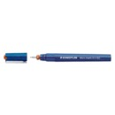](https://www.staedtler.com/en/products/technical-drawing-instruments/technical-pens/)](https://www.staedtler.com/en/products/technical-drawing-instruments/technical-pens/)

### [Technical pens](https://www.staedtler.com/en/products/technical-drawing-instruments/technical-pens/)

[More](https://www.staedtler.com/en/products/technical-drawing-instruments/technical-pens/)

[[](https://www.staedtler.com/en/products/technical-drawing-instruments/drawing-ink/)](https://www.staedtler.com/en/products/technical-drawing-instruments/drawing-ink/)

### [Drawing ink](https://www.staedtler.com/en/products/technical-drawing-instruments/drawing-ink/)

[More](https://www.staedtler.com/en/products/technical-drawing-instruments/drawing-ink/)

[[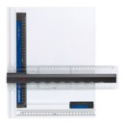](https://www.staedtler.com/en/products/technical-drawing-instruments/drawing-boards/)](https://www.staedtler.com/en/products/technical-drawing-instruments/drawing-boards/)

### [Drawing boards](https://www.staedtler.com/en/products/technical-drawing-instruments/drawing-boards/)

[More](https://www.staedtler.com/en/products/technical-drawing-instruments/drawing-boards/)

[[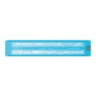](https://www.staedtler.com/en/products/technical-drawing-instruments/lettering-guides/)](https://www.staedtler.com/en/products/technical-drawing-instruments/lettering-guides/)

### [Lettering guides](https://www.staedtler.com/en/products/technical-drawing-instruments/lettering-guides/)

[More](https://www.staedtler.com/en/products/technical-drawing-instruments/lettering-guides/)

[[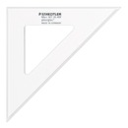](https://www.staedtler.com/en/products/technical-drawing-instruments/rulers-set-squares/)](https://www.staedtler.com/en/products/technical-drawing-instruments/rulers-set-squares/)

### [Rulers & set squares](https://www.staedtler.com/en/products/technical-drawing-instruments/rulers-set-squares/)

[More](https://www.staedtler.com/en/products/technical-drawing-instruments/rulers-set-squares/)

[[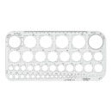](https://www.staedtler.com/en/products/technical-drawing-instruments/drawing-accessories/)](https://www.staedtler.com/en/products/technical-drawing-instruments/drawing-accessories/)

### [Drawing accessories](https://www.staedtler.com/en/products/technical-drawing-instruments/drawing-accessories/)

[More](https://www.staedtler.com/en/products/technical-drawing-instruments/drawing-accessories/)

[[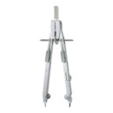](https://www.staedtler.com/en/products/technical-drawing-instruments/compasses/)](https://www.staedtler.com/en/products/technical-drawing-instruments/compasses/)

### [Compasses](https://www.staedtler.com/en/products/technical-drawing-instruments/compasses/)

Chapter - 1A

DRAWING INSTRUMENTS

AND THEIR USES

Drawing Instruments are used to prepare neat and accurate Drawings. To a greater extent, the ac-

curacy of the Drawings depend on the quality of instruments used to prepare them. The following is the list

of Drawing Instruments and other materials required.

a)

Drawing Board

b)

T-square or Drafter (Drafting machine)

c)

Set Squares

d)

Protractor

e)

Drawing Instrument Box

f)

Drawing Sheet

g)

Drawing Pencils

h)

Drawing Pins/Clips

a) Drawing Board :

Drawing board is made from strips of well seasoned soft wood generally 25 mm thick. It is cleated

at the back by two battens to prevent warping. One of the shorter edges of the rectangular board is pro-

vided with perfectly straight ebony edge which is used as working edge on which the T-square is moved

while making Drawings.

Battens

Working edge

(ebony)

Fig. 1A.1

Note:

When Minidrafter (Drafting machine) is used to prepare Drawings, the working edge is not

used.

2

Computer Aided Engineering Drawing

Drawing board size:

Drawing boards are made in various sizes. The selection of Drawing board depends on the size of

drawing paper used. The sizes of Drawing board recommended by Bureau of Indian Standards (B.I.S) is given

below

Standard size of Drawing boards

Designation

Size (mm)

Designation

Size (mm)

B0

1500 × 1000

B3

500 × 350

B1

1000 × 700

B4

250 × 350

B2

700 × 500

b) T-square :

T-squares are made from hard wood. A T-square consists of two parts namely the stock and the

blade joined together at right angles to each other by means of screws and Pins as shown in figure 1A.2. The

stock is made to slide along the working edge and the Blade moves on the Drawing board.

Wo r k i n g e d g e

Blade

Stock

Screws

Fig. 1A.2

The working edge of T-square is used to draw parallel lines, vertical lines or inclined lines at 30

°

, 60

o

to the horizontal using set squares.

Drafting machine (or Drafter):

In a Drafting machine, the uses and advantages of T-square, set square, scales, protractors are

combined. One end of the Drafter is clamped at the left top end of the Drawing board by a screw provided

in the drafter.

An adjustable head with a Protractor is fitted at the other end of the Drafter. Two blades made of

transparent celluloid material are fitted to the adjustable head and are perfectly perpendicular to each other.

These blades are used to draw parallel, horizontal, vertical and inclined lines. The blades always move parallel

to the edges of the board. Use of Drafting machine helps in reducing the time required to prepare Drawing.

Drawing Instruments and their Uses

3

Scale

Scale

Potractor

Angle

Drawing sheet

Drawing board

Parallel bar arm

Parallel bar arm

Fig. 1A.3

c) Set Squares :

Set squares are generally made from Plastic or celluloid material. They are triangular in shape with

one corner, a right angle triangle. A pair of set squares (30

°

–60

°

) and 45

°

(45

°

set square are generally pro-

vided with Protractor) facilitate marking of angles as shown in figures 1A.4 and 1A.5.

They are used to draw lines at 30

°

, 60

°

and 45

°

to the vertical and horizontal.

mm

g

. 1A.6. 45 Set Square with Protractor

0

d) Protractor:

Protractors are used to mark or measure angles between 0 and 180

°

. They are semicircular in shape

(of diameter 100mm) and are made of Plastic or celluloid which has more life. Protractors with circular shape

capable of marking and measuring 0 to 360

°

are also available in the market.

180

e) Drawing Instrument Box :

It consists of the following

a) Large size compasses,

b) Large size divider,

c) Small size bow pen, bow divider, and

d) Lengthening bar

f) Drawing sheet:

They are available in many varieties and good quality paper with smooth surface should be selected

for Drawings which are to be preserved for longer time. Sizes of Drawing Sheets recommended by Bureau

of Indian Standards (B.I.S) is given below,

Drawing Instruments and their Uses

5

Standard size of Drawing sheet

Designation

Size (mm)

Designation

Size (mm)

A0

1189 × 841

A3

420 × 297

A1

841 × 594

A4

297 × 210

A2

594 × 420

A5

210 × 148

g) Drawing Pencils:

The accuracy and appearance of a Drawing depends on the quality of Pencil used to make Draw-

ing. The grade of a Pencil lead is marked on the Pencil. HB denotes medium grade. Increase in hardness

is shown by value put in front of H such as 2H, 3H etc., Softer pencils are marked as 2B, 3B, 4B etc. A

Pencil marked 3B is softer than 2B and Pencil marked 4B is softer than 3B and so on. Beginning of a Draw-

ing may be made with H or 2H. For lettering and dimensioning, H and HB Pencils are used.

h) Drawing Pins and clips:

These are used to fix the Drawing sheet on the Drawing board.

Compass:

Compass is used for drawing circles and arcs of circles. The compass has two legs hinged at one

end. One of the legs has a pointed needle fitted at the lower end where as the other end has provision for

inserting pencil lead. Circles upto 120mm diameters are drawn by keeping the legs of compass straight. For

drawing circles more than 150 mm radius, a lengthening bar is used. It is advisable to keep the needle end

about 1mm long compared to that of pencil end so that while drawing circles, when the needle end is pressed

it goes inside the drawing sheet by a small distance (approximately 1mm).

assignment

1. List 5 uses of drawing instrument
2. Draw set squares

week 5; care of drawing instruments

# Cleaning, maintaining and preserving your Drawing material

[Twitter icon](http://twitter.com/share?url=http://www.cansonstudio.com/cleaning-maintaining-and-preserving-your-drawing-material&text=Cleaning,%20maintaining%20and%20preserving%20your%20Drawing%20material%20%20http://www.cansonstudio.com/cleaning-maintaining-and-preserving-your-drawing-material%20via%20@CansonPaper)

[http://www.cansonstudio.com/sites/all/themes/passerelle/cansonconseils/canson_commons/images/article-save.png](http://www.cansonstudio.com/printpdf/518)[http://www.cansonstudio.com/sites/all/themes/passerelle/cansonconseils/canson_commons/images/article-print.png](http://www.cansonstudio.com/print/518)[http://www.cansonstudio.com/sites/all/themes/passerelle/cansonconseils/canson_commons/images/article-fav.png](http://www.cansonstudio.com/cleaning-maintaining-and-preserving-your-drawing-material)

[Art Material](http://www.cansonstudio.com/art-material)

Rate this article

Top of Form

[Give Cleaning, maintaining and preserving your Drawing material 1/5](http://www.cansonstudio.com/cleaning-maintaining-and-preserving-your-drawing-material#20)

[Give Cleaning, maintaining and preserving your Drawing material 2/5](http://www.cansonstudio.com/cleaning-maintaining-and-preserving-your-drawing-material#40)

[Give Cleaning, maintaining and preserving your Drawing material 3/5](http://www.cansonstudio.com/cleaning-maintaining-and-preserving-your-drawing-material#60)

[Give Cleaning, maintaining and preserving your Drawing material 4/5](http://www.cansonstudio.com/cleaning-maintaining-and-preserving-your-drawing-material#80)

[Give Cleaning, maintaining and preserving your Drawing material 5/5](http://www.cansonstudio.com/cleaning-maintaining-and-preserving-your-drawing-material#100)

Bottom of Form

Every medium has its frailties. It's up to you to take care of them!

## 1. ****Rules of thumb****

Caution: fragile media!

* When transporting your tools and drawing, carefully put your media away in cases. Charcoal is very volatile and drops its pigments on your paper and on the table, not to mention graphite pencils, color pencils and pastels, which roll, fall and break.
* Try, as best as you can, to keep your workspace clean. You should always have a clean, dry rag or absorbent paper nearby to wipe your hands.

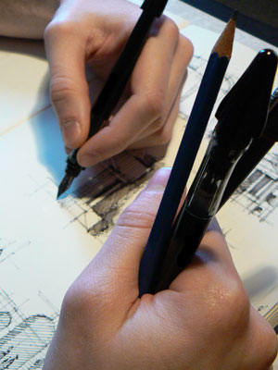

## 2. ****Caring for your tools with leads****

​

The leads in graphite pencils and color pencils often break, even inside their wood casings. Protect them from shocks. When working with several pencils at once, avoid constantly laying them down and picking them up again. It's better to hold them in the hand that isn't drawing**.**

To properly clean your color pencils after sharpening them, pass over the lead with a paintbrush to remove the color residue.

**Tip**: Sharpen your pencils by hand. Sharpening your pencils with a knife or utility knife gives you better control of the form, length and support you give to your lead. You can also use lead in a mechanical pencil, which is more solid.

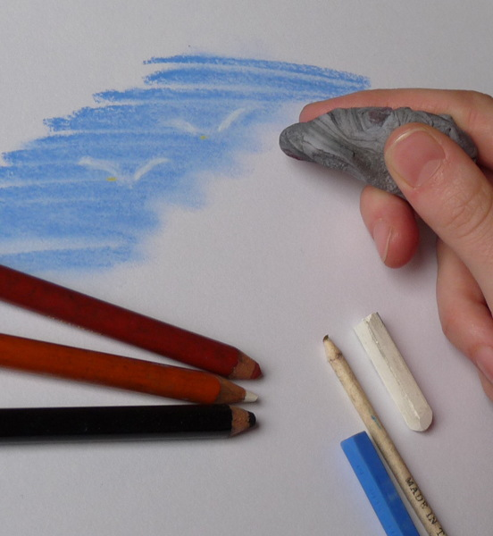

## 3. ****Clean your erasers****

If your eraser soils your drawing, it's too dirty...

* Clean classical erasers by rubbing them with a cotton cloth or washing them in soapy water (don't forget to dry them before using them).
* Kneaded erasers are self-cleaning. By kneading them, you enclose the charcoal pigment inside the eraser and use a clean part. When the eraser becomes saturated with pigment, throw it out.

## 4. ****Fix your media****

Charcoal, dry sanguine and chalk are all unstable media. To preserve your creations, fix them on the paper.

Assignment

1. How can we care for drawing instruments [explain]

Week 6; board practice

## Saturday, 26 October 2013

### JSS 1. TOPIC 5: DRAWING PRACTICE: Drawing Instruments and Materials

Drawing practice is simply technical drawing. Technical drawing is the language used by engineers and architects to interpret objects, symbols, lines, curves and conventional representations on paper.

**Drawing Instruments:**Drawing instruments are tools used in technical drawing that do not get consumed while using them. They include the following:

(i). **Drawing Board:** This is a flat wooden board with a smooth, rigid surface. It is suitable for  A3 paper.

[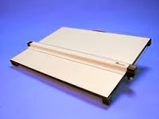](http://2.bp.blogspot.com/-Yz33s_7ndbc/Umv0osGV31I/AAAAAAAAAs0/vOXUAVN9Rlw/s1600/imagesCAAET100.jpg)

(ii). **Tee-square:** This is a T-shape instrument containing a head and a stock. It is used for drawing all horizontal lines and for setting the paper on the board.

[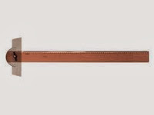](http://1.bp.blogspot.com/-HBTHOH9d7i8/Umv3IWYq0BI/AAAAAAAAAtI/lbyf8l9wVy8/s1600/imagesCA401NK0.jpg)

(iii). **Set-square:** We have the 450 and 300/600 set-squares. They are used for drawing vertical and angled lines.

[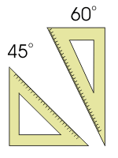](http://2.bp.blogspot.com/-1LHvuZ3fTVw/Umv22b7E__I/AAAAAAAAAtA/SHeUfAm5Jkw/s1600/eq8%5b1%5d.gif)

 (iv). **Rules:** This is a 30cm wooden or plastic instrument, used for measuring lengths and for dimensioning scaled drawings.

[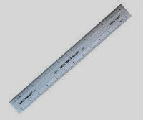](http://4.bp.blogspot.com/-Eh0qAgm4BqA/Umv4SNh7L2I/AAAAAAAAAtU/YRC5RBwCkKQ/s1600/imagesCASILQFR.jpg)

(v). **Protractor:** The protractor is used for measuring angles in degrees.

[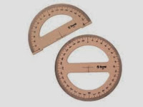](http://3.bp.blogspot.com/-c-nsIjtxJIA/Umv7CvMewmI/AAAAAAAAAtg/qW21v2PcMpU/s1600/imagesCAOCVY9J.jpg)

(vi). **French curves:** This instrument is used to draw different shapes of curves.

[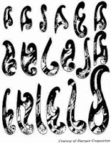](http://2.bp.blogspot.com/-Io63VfCzuMY/UmwScINjg9I/AAAAAAAAAt0/t2FD64lZOn4/s1600/14069_68_1%5B1%5D.jpg)

(vii). **Drawing set:** This is a pack containing different drawing items like pair of compasses, divider, etc.

**Drawing Materials:**Drawing materials on the other hand, are items that get consumed with use. They include the following:  
  
(i). **Drawing paper:** The paper commonly used for technical drawing is the A3 paper. Other drawing papers are the A1, A2, A4, etc, depending on the work to be done.  
(ii). **Pencil:** The2H pencil is used for construction lines, ‘H’ is for lettering and thickening of visible lines. The HB pencil is good for free-hand sketching.  
(iii). **Pencil sharpeners:** This is a material used to sharpen all pencils to a conical point shape.  
(iv).**Emery cloth:**  Instead of re-sharpening the pencil, this material is used to restore sharpness to the pencil.  
(v). **Brush:**  The brush is used to remove dirt from the paper after erasing.  
(vi). **Eraser:** This material is used to remove mistakes. It is made of soft quality rubber.

**Care and Storage of Drawing Instruments and Materials.**

To care for their drawing instruments, students should do the following:  
  
(i). Do not use any sharp objects on the edges of the drawing board.  
(ii). When not in use, cover the face of the board to avoid dust.  
(iii).The Tee-square should not be used as a sword or staff to play with.  
(iv). Never use any sharp object on the edges of your set-squares.  
(v). When you are not working with your instruments, keep them on their sheaths and packs.  
(vi). Drawing paper should be kept in a flat file or jacket.

**REVIEW QUESTIONS**

(i). Define drawing practice.  
(ii). What is the difference between drawing instrument and drawing material?

**ASSIGNMENT  
State the uses of the following drawing instruments and drawing materials:**i. Tee square  
ii. Sketch pad  
iii. Set square  
iv. Eraser  
v. HB pencil

**Week 7; board practice [lettering]**

### JSS 1. TOPIC 5: DRAWING PRACTICE: Drawing Instruments and Materials

Drawing practice is simply technical drawing. Technical drawing is the language used by engineers and architects to interpret objects, symbols, lines, curves and conventional representations on paper.

**Drawing Instruments:**Drawing instruments are tools used in technical drawing that do not get consumed while using them. They include the following:

(i). **Drawing Board:** This is a flat wooden board with a smooth, rigid surface. It is suitable for  A3 paper.

[](http://2.bp.blogspot.com/-Yz33s_7ndbc/Umv0osGV31I/AAAAAAAAAs0/vOXUAVN9Rlw/s1600/imagesCAAET100.jpg)

(ii). **Tee-square:** This is a T-shape instrument containing a head and a stock. It is used for drawing all horizontal lines and for setting the paper on the board.

[](http://1.bp.blogspot.com/-HBTHOH9d7i8/Umv3IWYq0BI/AAAAAAAAAtI/lbyf8l9wVy8/s1600/imagesCA401NK0.jpg)

(iii). **Set-square:** We have the 450 and 300/600 set-squares. They are used for drawing vertical and angled lines.

[](http://2.bp.blogspot.com/-1LHvuZ3fTVw/Umv22b7E__I/AAAAAAAAAtA/SHeUfAm5Jkw/s1600/eq8%5b1%5d.gif)

 (iv). **Rules:** This is a 30cm wooden or plastic instrument, used for measuring lengths and for dimensioning scaled drawings.

[](http://4.bp.blogspot.com/-Eh0qAgm4BqA/Umv4SNh7L2I/AAAAAAAAAtU/YRC5RBwCkKQ/s1600/imagesCASILQFR.jpg)

(v). **Protractor:** The protractor is used for measuring angles in degrees.

[](http://3.bp.blogspot.com/-c-nsIjtxJIA/Umv7CvMewmI/AAAAAAAAAtg/qW21v2PcMpU/s1600/imagesCAOCVY9J.jpg)

(vi). **French curves:** This instrument is used to draw different shapes of curves.

[](http://2.bp.blogspot.com/-Io63VfCzuMY/UmwScINjg9I/AAAAAAAAAt0/t2FD64lZOn4/s1600/14069_68_1%5B1%5D.jpg)

(vii). **Drawing set:** This is a pack containing different drawing items like pair of compasses, divider, etc.

**Drawing Materials:**Drawing materials on the other hand, are items that get consumed with use. They include the following:  
  
(i). **Drawing paper:** The paper commonly used for technical drawing is the A3 paper. Other drawing papers are the A1, A2, A4, etc, depending on the work to be done.  
(ii). **Pencil:** The2H pencil is used for construction lines, ‘H’ is for lettering and thickening of visible lines. The HB pencil is good for free-hand sketching.  
(iii). **Pencil sharpeners:** This is a material used to sharpen all pencils to a conical point shape.  
(iv).**Emery cloth:**  Instead of re-sharpening the pencil, this material is used to restore sharpness to the pencil.  
(v). **Brush:**  The brush is used to remove dirt from the paper after erasing.  
(vi). **Eraser:** This material is used to remove mistakes. It is made of soft quality rubber.

**Care and Storage of Drawing Instruments and Materials.**

To care for their drawing instruments, students should do the following:  
  
(i). Do not use any sharp objects on the edges of the drawing board.  
(ii). When not in use, cover the face of the board to avoid dust.  
(iii).The Tee-square should not be used as a sword or staff to play with.  
(iv). Never use any sharp object on the edges of your set-squares.  
(v). When you are not working with your instruments, keep them on their sheaths and packs.  
(vi). Drawing paper should be kept in a flat file or jacket.

**REVIEW QUESTIONS**

(i). Define drawing practice.  
(ii). What is the difference between drawing instrument and drawing material?

**ASSIGNMENT  
State the uses of the following drawing instruments and drawing materials:**i. Tee square  
ii. Sketch pad  
iii. Set square  
iv. Eraser  
v. HB pencil

April 3, 2017 by [admin](http://www.drawinghowtodraw.com/stepbystepdrawinglessons/author/admin/) [1 Comment](http://www.drawinghowtodraw.com/stepbystepdrawinglessons/2017/04/draw-cool-3d-letters-popping-paper-easy-step-step-drawing-tutorial-beginners/#comments)

[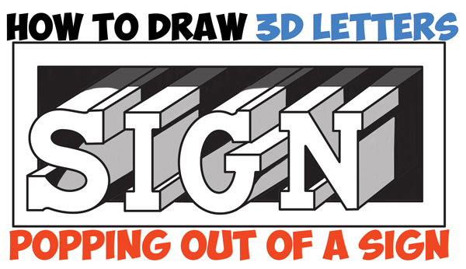](http://www.drawinghowtodraw.com/stepbystepdrawinglessons/2017/04/draw-cool-3d-letters-popping-paper-easy-step-step-drawing-tutorial-beginners/)

Today I'll show you how to draw letters popping out of a sign or piece of paper. The following easy step by step drawing tutorial will guide you through the process. Happy Drawing!

Posted in: [How to Draw Cool Stuff](http://www.drawinghowtodraw.com/stepbystepdrawinglessons/category/how-to-draw-cool-stuff/), [Lettering and Drawing Letters](http://www.drawinghowtodraw.com/stepbystepdrawinglessons/category/lettering-and-drawing-letters/) Tagged: [3-d letters](http://www.drawinghowtodraw.com/stepbystepdrawinglessons/tag/3-d-letters/), [3-dimensional letters](http://www.drawinghowtodraw.com/stepbystepdrawinglessons/tag/3-dimensional-letters/), [3d lettering](http://www.drawinghowtodraw.com/stepbystepdrawinglessons/tag/3d-lettering/), [3d letters](http://www.drawinghowtodraw.com/stepbystepdrawinglessons/tag/3d-letters/), [cool lettering](http://www.drawinghowtodraw.com/stepbystepdrawinglessons/tag/cool-lettering/), [cool letters](http://www.drawinghowtodraw.com/stepbystepdrawinglessons/tag/cool-letters/), [drawing type](http://www.drawinghowtodraw.com/stepbystepdrawinglessons/tag/drawing-type/), [lettering](http://www.drawinghowtodraw.com/stepbystepdrawinglessons/tag/lettering/), [letters popping out](http://www.drawinghowtodraw.com/stepbystepdrawinglessons/tag/letters-popping-out/), [typography](http://www.drawinghowtodraw.com/stepbystepdrawinglessons/tag/typography/)

## [How to Draw Cool 3D Interlocking Letters in Easy Step by Step Drawing Tutorial for Kids and Beginners](http://www.drawinghowtodraw.com/stepbystepdrawinglessons/2016/12/draw-cool-3d-interlocking-letters-easy-step-step-drawing-tutorial-kids-beginners/)

December 11, 2016 by [admin](http://www.drawinghowtodraw.com/stepbystepdrawinglessons/author/admin/) [Leave a Comment](http://www.drawinghowtodraw.com/stepbystepdrawinglessons/2016/12/draw-cool-3d-interlocking-letters-easy-step-step-drawing-tutorial-kids-beginners/#respond)

[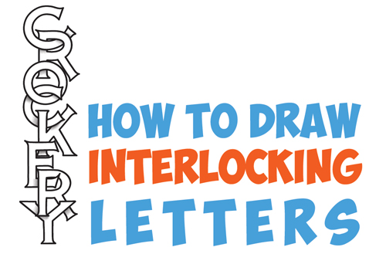](http://www.drawinghowtodraw.com/stepbystepdrawinglessons/2016/12/draw-cool-3d-interlocking-letters-easy-step-step-drawing-tutorial-kids-beginners/)

Today I'll show you how to draw these cool 3-dimensional letters. Each of these letters is interlocked together...they are hanging off of each other. This is a really cool, yet easy lettering effect that you will enjoy drawing or doodle. Happy Drawing!

Posted in: [How to Draw Cool Stuff](http://www.drawinghowtodraw.com/stepbystepdrawinglessons/category/how-to-draw-cool-stuff/), [Lettering and Drawing Letters](http://www.drawinghowtodraw.com/stepbystepdrawinglessons/category/lettering-and-drawing-letters/) Tagged: [3d letters](http://www.drawinghowtodraw.com/stepbystepdrawinglessons/tag/3d-letters/), [cool letters](http://www.drawinghowtodraw.com/stepbystepdrawinglessons/tag/cool-letters/), [how to draw cool letters](http://www.drawinghowtodraw.com/stepbystepdrawinglessons/tag/how-to-draw-cool-letters/), [interlocked letters](http://www.drawinghowtodraw.com/stepbystepdrawinglessons/tag/interlocked-letters/), [interlocking letters](http://www.drawinghowtodraw.com/stepbystepdrawinglessons/tag/interlocking-letters/), [overlapped letters](http://www.drawinghowtodraw.com/stepbystepdrawinglessons/tag/overlapped-letters/), [overlapping letters](http://www.drawinghowtodraw.com/stepbystepdrawinglessons/tag/overlapping-letters/)

## [How to Draw 3D Letters, Stacked and at an Angle – Easy Step by Step Drawing Tutorial for Beginners](http://www.drawinghowtodraw.com/stepbystepdrawinglessons/2016/11/draw-3d-letters-stacked-angle-easy-step-step-drawing-tutorial-beginners/)

November 18, 2016 by [admin](http://www.drawinghowtodraw.com/stepbystepdrawinglessons/author/admin/) [Leave a Comment](http://www.drawinghowtodraw.com/stepbystepdrawinglessons/2016/11/draw-3d-letters-stacked-angle-easy-step-step-drawing-tutorial-beginners/#respond)

[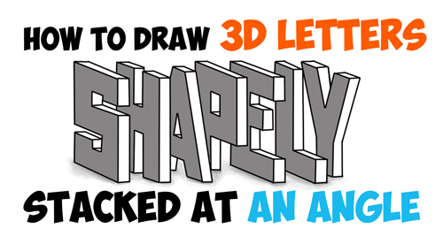](http://www.drawinghowtodraw.com/stepbystepdrawinglessons/2016/11/draw-3d-letters-stacked-angle-easy-step-step-drawing-tutorial-beginners/)

Today I'll show you how to draw cool 3D letters that are turned at a sharp angle (45 degrees towards the viewer) and stacked. We will guide you through the steps so that it is easy for you to learn how to draw. We will also show you how to cast a shadow.

Posted in: [How to Draw Cool Stuff](http://www.drawinghowtodraw.com/stepbystepdrawinglessons/category/how-to-draw-cool-stuff/), [Lettering and Drawing Letters](http://www.drawinghowtodraw.com/stepbystepdrawinglessons/category/lettering-and-drawing-letters/) Tagged: [3-dimensional letters](http://www.drawinghowtodraw.com/stepbystepdrawinglessons/tag/3-dimensional-letters/), [draw 3d letters](http://www.drawinghowtodraw.com/stepbystepdrawinglessons/tag/draw-3d-letters/), [drawing 3d letters](http://www.drawinghowtodraw.com/stepbystepdrawinglessons/tag/drawing-3d-letters/), [how to draw 3d letters](http://www.drawinghowtodraw.com/stepbystepdrawinglessons/tag/how-to-draw-3d-letters/), [how to draw letters at an angle](http://www.drawinghowtodraw.com/stepbystepdrawinglessons/tag/how-to-draw-letters-at-an-angle/), [letters at an angle](http://www.drawinghowtodraw.com/stepbystepdrawinglessons/tag/letters-at-an-angle/), [stacked letters](http://www.drawinghowtodraw.com/stepbystepdrawinglessons/tag/stacked-letters/)

## [How to Draw Cool 3D Letters Wrapped Around, Over, and Under Notebook Paper Lines – Easy Steps Drawing Tutorial for Kids](http://www.drawinghowtodraw.com/stepbystepdrawinglessons/2016/11/draw-cool-3d-letters-wrapped-around-notebook-paper-lines-easy-steps-drawing-tutorial-kids/)

November 16, 2016 by [admin](http://www.drawinghowtodraw.com/stepbystepdrawinglessons/author/admin/) [2 Comments](http://www.drawinghowtodraw.com/stepbystepdrawinglessons/2016/11/draw-cool-3d-letters-wrapped-around-notebook-paper-lines-easy-steps-drawing-tutorial-kids/#comments)

[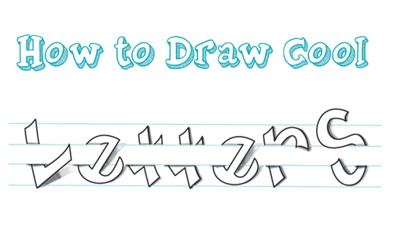](http://www.drawinghowtodraw.com/stepbystepdrawinglessons/2016/11/draw-cool-3d-letters-wrapped-around-notebook-paper-lines-easy-steps-drawing-tutorial-kids/)

Today I will show you how to draw these cool 3-dimensional letters that seem to be going around, under, and over notebook paper. This is a cool and fun doodling idea for when you are bored. The following simple step by step drawing instructions / lesson will guide you through the steps of drawing these cool letters. Have fun!

Posted in: [drawing lessons for kids](http://www.drawinghowtodraw.com/stepbystepdrawinglessons/category/drawing-lessons-for-kids/), [Drawing Tricks](http://www.drawinghowtodraw.com/stepbystepdrawinglessons/category/drawing-tricks/), [How to Draw Cool Stuff](http://www.drawinghowtodraw.com/stepbystepdrawinglessons/category/how-to-draw-cool-stuff/), [Lettering and Drawing Letters](http://www.drawinghowtodraw.com/stepbystepdrawinglessons/category/lettering-and-drawing-letters/) Tagged: [3d letters](http://www.drawinghowtodraw.com/stepbystepdrawinglessons/tag/3d-letters/), [cool lettering](http://www.drawinghowtodraw.com/stepbystepdrawinglessons/tag/cool-lettering/), [how to draw 3d letters](http://www.drawinghowtodraw.com/stepbystepdrawinglessons/tag/how-to-draw-3d-letters/), [how to draw cool letters](http://www.drawinghowtodraw.com/stepbystepdrawinglessons/tag/how-to-draw-cool-letters/), [how to draw letters](http://www.drawinghowtodraw.com/stepbystepdrawinglessons/tag/how-to-draw-letters/), [lettering](http://www.drawinghowtodraw.com/stepbystepdrawinglessons/tag/lettering/), [notebook paper](http://www.drawinghowtodraw.com/stepbystepdrawinglessons/tag/notebook-paper/), [notebook paper effect](http://www.drawinghowtodraw.com/stepbystepdrawinglessons/tag/notebook-paper-effect/), [notebook paper illusion](http://www.drawinghowtodraw.com/stepbystepdrawinglessons/tag/notebook-paper-illusion/)

## [Learn How to Turn 6 Lines into The Coolest Letter S – Easy Step by Step Drawing Tutorial for Kids](http://www.drawinghowtodraw.com/stepbystepdrawinglessons/2016/05/learn-turn-6-lines-coolest-letter-s-easy-step-step-drawing-tutorial-kids/)

May 10, 2016 by [admin](http://www.drawinghowtodraw.com/stepbystepdrawinglessons/author/admin/) [2 Comments](http://www.drawinghowtodraw.com/stepbystepdrawinglessons/2016/05/learn-turn-6-lines-coolest-letter-s-easy-step-step-drawing-tutorial-kids/#comments)

[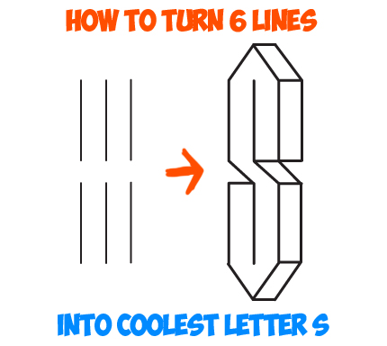](http://www.drawinghowtodraw.com/stepbystepdrawinglessons/2016/05/learn-turn-6-lines-coolest-letter-s-easy-step-step-drawing-tutorial-kids/)

When I was growing up in the 80s and 90s, this was one of my favorite things to doodle. It is so easy to draw and it makes you look like you are a fantastic drawer. And I wasn't the only one to draw this cool, 3d looking letter 'S'...all the kids were doing it. Learn how to draw this easy futuristic letter 'S' starting with 6 lines.

Posted in: [drawing lessons for kids](http://www.drawinghowtodraw.com/stepbystepdrawinglessons/category/drawing-lessons-for-kids/), [How to Draw Cool Stuff](http://www.drawinghowtodraw.com/stepbystepdrawinglessons/category/how-to-draw-cool-stuff/), [Lettering and Drawing Letters](http://www.drawinghowtodraw.com/stepbystepdrawinglessons/category/lettering-and-drawing-letters/) Tagged: [3-dimensional letters](http://www.drawinghowtodraw.com/stepbystepdrawinglessons/tag/3-dimensional-letters/), [3d letters](http://www.drawinghowtodraw.com/stepbystepdrawinglessons/tag/3d-letters/), [cool drawing](http://www.drawinghowtodraw.com/stepbystepdrawinglessons/tag/cool-drawing/), [doodles](http://www.drawinghowtodraw.com/stepbystepdrawinglessons/tag/doodles/), [doodling](http://www.drawinghowtodraw.com/stepbystepdrawinglessons/tag/doodling/), [fun drawing](http://www.drawinghowtodraw.com/stepbystepdrawinglessons/tag/fun-drawing/), [letter s](http://www.drawinghowtodraw.com/stepbystepdrawinglessons/tag/letter-s/)

## [How to Draw 3-Dimensional Letters with 2 Point Perspective – Simple Drawing Tutorial](http://www.drawinghowtodraw.com/stepbystepdrawinglessons/2016/04/draw-3-dimensional-letters-2-point-perspective-simple-drawing-tutorial/)

April 8, 2016 by [admin](http://www.drawinghowtodraw.com/stepbystepdrawinglessons/author/admin/) [Leave a Comment](http://www.drawinghowtodraw.com/stepbystepdrawinglessons/2016/04/draw-3-dimensional-letters-2-point-perspective-simple-drawing-tutorial/#respond)

[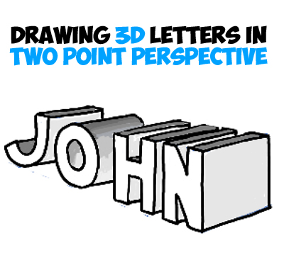](http://www.drawinghowtodraw.com/stepbystepdrawinglessons/2016/04/draw-3-dimensional-letters-2-point-perspective-simple-drawing-tutorial/)

Making these 3 dimensional letters looks like a lot of work, but trust me, drawing these are easy. All you have to do is learn the perspective drawing techniques and you will be able to draw anything with depth and 3-dimensionality. Find out how now.

Posted in: [How to Draw Cool Stuff](http://www.drawinghowtodraw.com/stepbystepdrawinglessons/category/how-to-draw-cool-stuff/), [Lettering and Drawing Letters](http://www.drawinghowtodraw.com/stepbystepdrawinglessons/category/lettering-and-drawing-letters/), [Perspective Drawing](http://www.drawinghowtodraw.com/stepbystepdrawinglessons/category/perspective-drawing/) Tagged: [2 point perspective](http://www.drawinghowtodraw.com/stepbystepdrawinglessons/tag/2-point-perspective/), [3-dimensional letters](http://www.drawinghowtodraw.com/stepbystepdrawinglessons/tag/3-dimensional-letters/), [3d letters](http://www.drawinghowtodraw.com/stepbystepdrawinglessons/tag/3d-letters/), [angular perspective](http://www.drawinghowtodraw.com/stepbystepdrawinglessons/tag/angular-perspective/), [drawing 3d letters](http://www.drawinghowtodraw.com/stepbystepdrawinglessons/tag/drawing-3d-letters/), [how to draw 3d letters](http://www.drawinghowtodraw.com/stepbystepdrawinglessons/tag/how-to-draw-3d-letters/), [letters in 2 point perspective](http://www.drawinghowtodraw.com/stepbystepdrawinglessons/tag/letters-in-2-point-perspective/), [letters in perspective](http://www.drawinghowtodraw.com/stepbystepdrawinglessons/tag/letters-in-perspective/), [two point perspective](http://www.drawinghowtodraw.com/stepbystepdrawinglessons/tag/two-point-perspective/)

## [How to Draw 3D Letters in One Point Perspective – Perspective Drawing Tutorial](http://www.drawinghowtodraw.com/stepbystepdrawinglessons/2016/04/draw-3d-letters-one-point-perspective-perspective-drawing-tutorial/)

[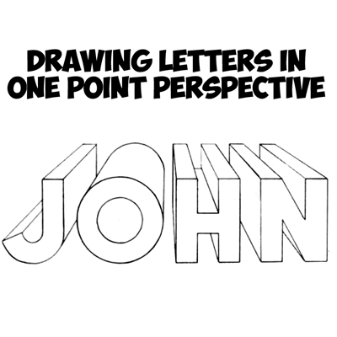](http://www.drawinghowtodraw.com/stepbystepdrawinglessons/2016/04/draw-3d-letters-one-point-perspective-perspective-drawing-tutorial/)

Assignment

1. Write letter a- z using lettering drawing

Week 8; free-hand sketching

### 01. Pencil grip

Think of the pencil as charcoal in a wooden sheath

When I draw, I use not the tip but the side of the lead in order to maximise its utility. Holding my pencil like I would charcoal also keeps it sharper longer. When covering large areas, I shade with my pencil perpendicular to the line I'm drawing to get wide, soft lines; for details, I hold my pencil parallel to my lines to get sharp, narrow marks. The only time I use the point is when I'm working on intricate details.

### 02. Shading techniques

Shading with unified lines versus with patches

I like to shade in two main ways: the first is with all of my lines going in the same direction, which makes my shading appear more cohesive. This pencil drawing technique also helps my details pop out from the lines I'm using for shading.

The second method I use is working in patches, which help define shape. Patches of lines go around the form, which help keep things in perspective. This technique is also great for backgrounds and adding texture.

### 03. Line weight

Line weight can help define solidity and volume

The next drawing technique concerns line weight. Having control over my line weight is a great way to separate objects from one another, and can help emphasise shadows. Thicker lines can fade and disappear into the shadows, which can help convey the 3D form.

I try to avoid outlining my drawings because this tends to make things look flat and deadens the 3D effect. Breaks and spaces in my lines show form in the lights and shadows.

### 04. Sketch language

Use light lines to explore and dark lines to commit

When I start drawing, I plan and explore using loose lines, and avoid committing too early with hard, dark lines. As I progress my lines will change; checking and rechecking my work is vital. I darken my lines and add details at the end. I don't focus on one area for too long to prevent overdrawing.

When drawing something symmetrical, I focus on the spaces between the lines, and of course keep reevaluating as I go along.

Assignment

1. What is free hand sketching
2. Draw hammer with free hand sketching

Week 8; free hand sketching [work shop tools]

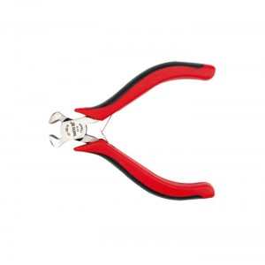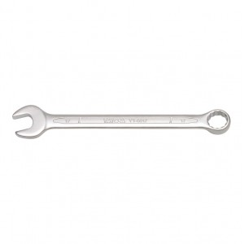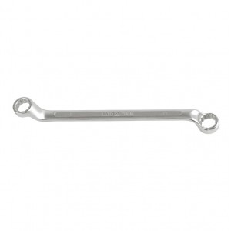

Week 9; freehand sketching

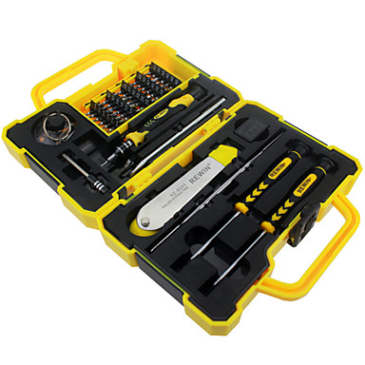

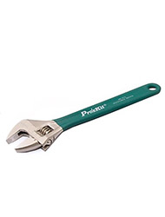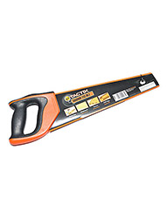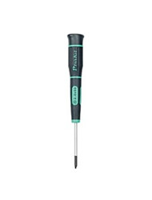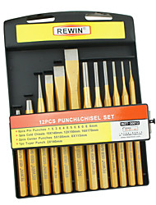

Question

1. Draw mallet
2. Draw hack saw with freehand sketching

Week 10; work bench fittings

|  |  |
| --- | --- |
|  |  |

[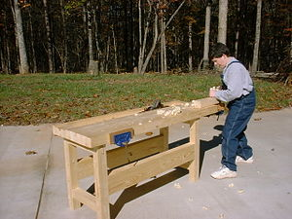](https://en.wikipedia.org/wiki/File:Basicbench.jpg)

A basic bench

A **workbench** is a table used by [woodworkers](https://en.wikipedia.org/wiki/Woodworking) to hold workpieces while they are worked by other tools. There are many styles of woodworking benches, each reflecting the type of work to be done or the craftsman's way of working. Most benches have two features in common: they are heavy and rigid enough to keep still while the wood is being worked, and there is some method for holding the work in place at a comfortable position and height so that the worker is free to use both hands on the tools. The main thing that distinguishes benches is the way in which the work is held in place. Most benches have more than one way to do this, depending on the operation being performed.

## https://pfollansbee.files.wordpress.com/2010/05/moxon-single-bench-screw-in-use.jpg?w=700

Assignment

1. Mention five work bench appliances
2. What is the function of work bench